COMSATS UNIVERSITY ISLAMABD (ATTOCK CAMPUS) 
NAME: FARYAL BIBI
REG# SP24-BSE-020
LAB TERMINAL
INFORMATION SECURITY
SUBMITTED TO MISS AMBREEN GUL

QUESTION :NO1
Scenario: You are designing a secure email communication system that ensures
confidentiality, integrity, and authenticity of messages. The system uses Elliptic Curve
Cryptography (ECC) for encryption and the Digital Signature Algorithm (DSA) for signing
messages.
Tasks:
1. Key Generation:
2. Encryption/Decryption using ECC:
3. Digital Signature and Verification using DSA

ANSWER:

Secure Email Communication System :

Scenario Overview:
A secure email communication system must protect messages from unauthorized access and tampering while ensuring that the sender is genuine. To achieve this, the system uses:

- Elliptic Curve Cryptography (ECC) for confidentiality
- Digital Signature Algorithm (DSA) for integrity and authenticity

1. Key Generation

ECC Key Generation

- The sender and receiver generate an ECC key pair.

- Each key pair consists of:

- Private Key (kept secret)
- Public Key (shared with others)

- The public key is used for encryption, while the private key is used for decryption.

DSA Key Generation

- The sender generates a DSA key pair:

- DSA Private Key: used to sign the message

- DSA Public Key: shared with the receiver for verification

2. Encryption and Decryption using ECC (Confidentiality)

Encryption Process

- The sender uses the receiver’s ECC public key to encrypt the email message.

- ECC uses mathematical properties of elliptic curves to securely generate a shared secret.
- The encrypted message (ciphertext) is sent to the receiver.

Decryption Process

- The receiver uses their ECC private key to decrypt the received ciphertext.

- Only the intended receiver can decrypt the message, ensuring confidentiality.

3. Digital Signature and Verification using DSA (Integrity & Authenticity)

Digital Signing

The sender creates a hash of the message.
The hash is encrypted using the sender’s DSA private key.
This encrypted hash is the digital signature, which is sent along with the message.

Signature Verification

- The receiver uses the sender’s DSA public key to decrypt the signature.

- The receiver computes the hash of the received message.

- If both hashes match:

- The message is authentic (sent by the claimed sender)

- The message has not been altered (integrity preserved)

Security Objectives Achieved
Security Property | Method Used
Confidentiality | ECC Encryption
Integrity | DSA Signature
Authenticity | DSA Verification

Conclusion
By combining ECC for encryption and DSA for digital signatures, the secure email communication system ensures that messages remain confidential, unaltered, and originate from a legitimate sender.
Here are some screen shot of code:
CODE
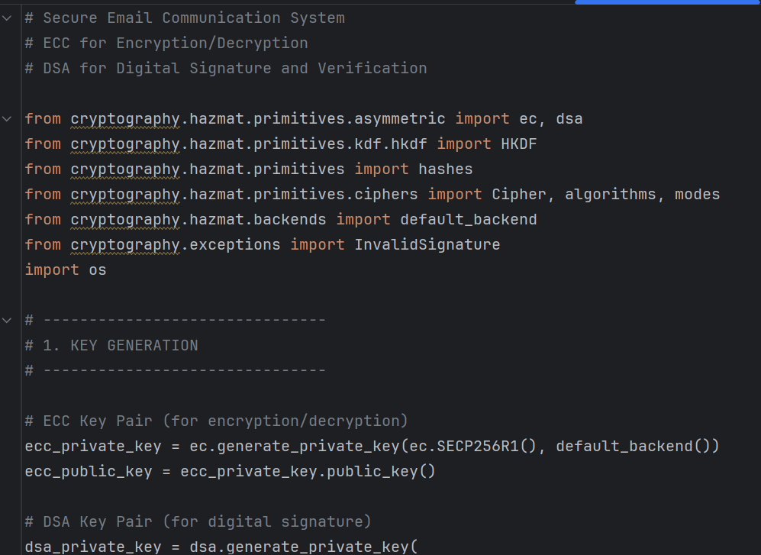
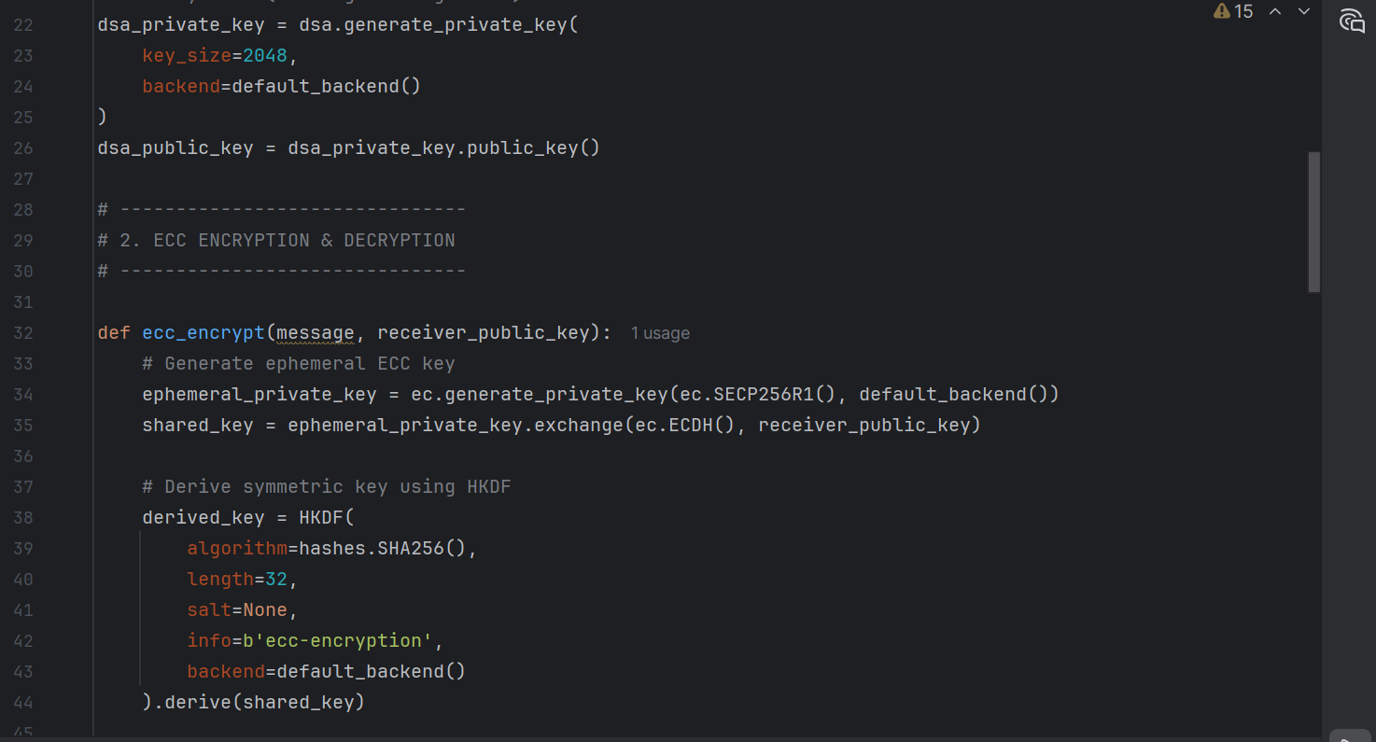
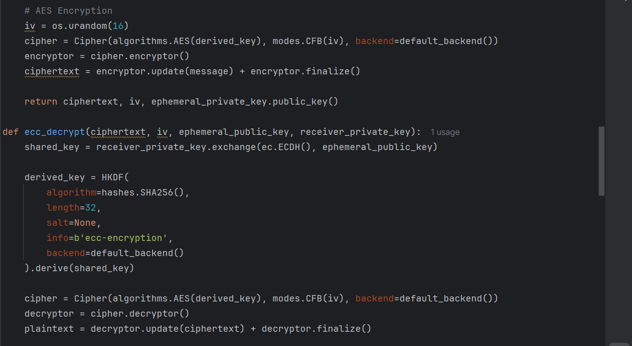
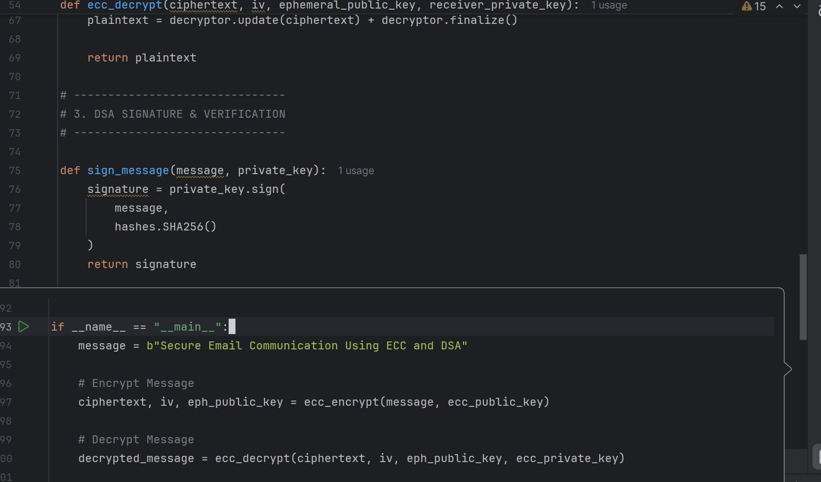
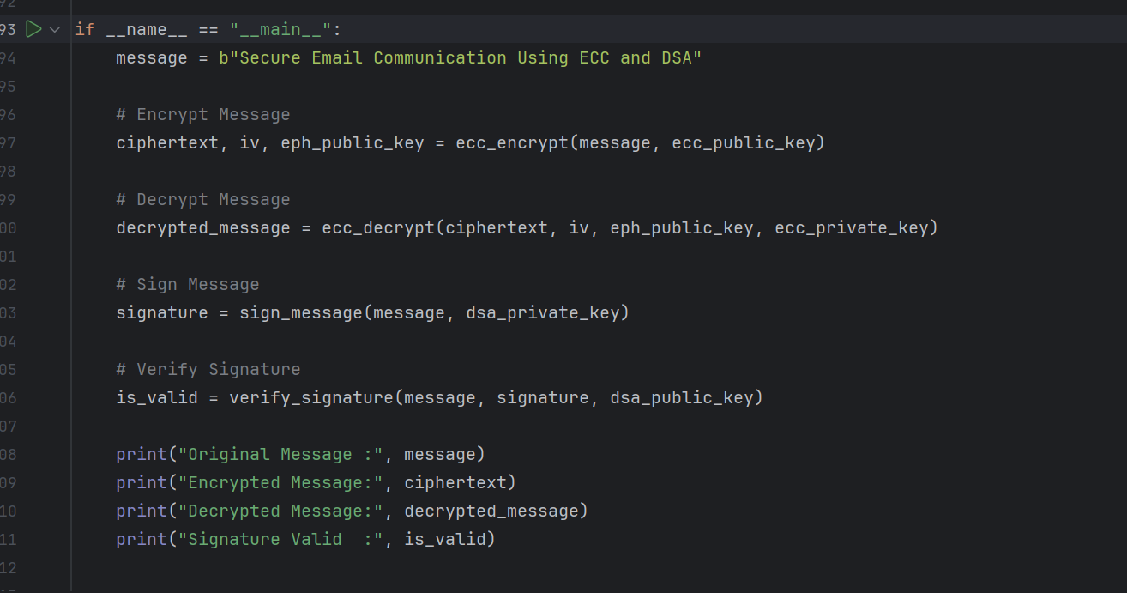
OUTPUT:
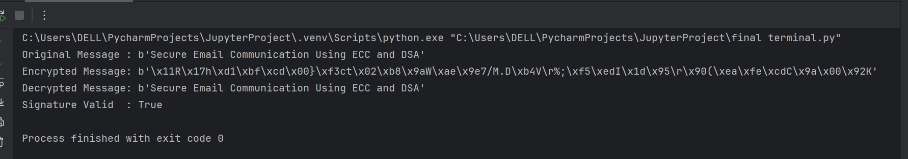
QUESTION NO:2
. You have developed a project during this course as your final submission. Using that same
project:
1. Justify your security method: Why is it suitable or better than other possible methods for
your type of project?
2. Identify one possible vulnerability or weakness in your current system. How could an
attacker misuse it?
3. Suggest one realistic improvement to enhance the security of your project. Briefly
explain how it would work.

Answers:
Security Analysis of Your Project:
1. Justify your security method:

Security Analysis of Your Project:

Method used: PBKDF2-HMAC-SHA256 with random salt for password hashing.

- Why suitable / better than other methods:

- Stronger than plain SHA-256 or MD5: Simple hash functions can be brute-forced quickly or attacked using rainbow tables. PBKDF2 adds key stretching, making attacks slower.

- Random salt prevents rainbow table attacks: Even if two users have the same password, their hashes are different.

- Widely used and tested in real-world systems: PBKDF2-HMAC-SHA256 is a standard in many secure applications (e.g., banking, web apps).

- Library-based approach ensures correctness: Built-in libraries handle cryptography securely, avoiding mistakes common in manual hashing.

2. Identify one possible vulnerability or weakness:
- Weakness: The system still depends on user-chosen passwords.

2:How it could be misused:

- If a user selects a weak password like "123456" or "password", an attacker could use dictionary attacks or brute-force attacks.

- Even though PBKDF2 slows down guesses, very weak passwords are still vulnerable.

3. Suggest one realistic improvement:

Improvement: Implement password strength validation and multi-factor authentication (MFA).
How it works:

- Password strength check: Require a minimum length, uppercase/lowercase letters, digits, and symbols to prevent easily guessable passwords.

- MFA: After password verification, require a one-time code (OTP) sent to email or phone.

- Effect: Even if an attacker guesses a password, they cannot log in without the second factor, significantly improving security.

